**#실습1**

**-코드**

<html>

<head>

<title>HTML TAG</title>

</head>

<body>

<table border='1' width='500px' height='500px' align='center' name='mytable'>

<tr>

<td></td>

<td></td>

<td></td>

<td></td>

<td></td>

<td></td>

<td></td>

<td></td>

<td></td>

<td></td>

</tr>

<tr>

<td></td>

<td></td>

<td></td>

<td></td>

<td></td>

<td></td>

<td></td>

<td colspan="2" rowspan="2" style="background-color:pink"></td>

<td></td>

</tr>

<tr>

<td></td>

<td></td>

<td></td>

<td colspan="1" rowspan="2" style="background-color:red"></td>

<td></td>

<td></td>

<td></td>

<td></td>

</tr>

<tr>

<td></td>

<td></td>

<td></td>

<td colspan="1" rowspan="2" style="background-color:red"></td>

<td></td>

<td></td>

<td></td>

<td></td>

<td></td>

</tr>

<tr>

<td></td>

<td></td>

<td></td>

<td></td>

<td></td>

<td></td>

<td></td>

<td></td>

<td></td>

</tr>

<tr>

<td colspan="1" rowspan="4" style="background-color:purple;"></td>

<td></td>

<td></td>

<td></td>

<td></td>

<td></td>

<td colspan="1" rowspan="2" style="background-color:red;"></td>

<td></td>

<td></td>

<td></td>

</tr>

<tr>

<td colspan="2" rowspan="1" style="background-color:green;"></td>

<td></td>

<td></td>

<td colspan="1" rowspan="2" style="background-color:red"></td>

<td></td>

<td></td>

<td></td>

</tr>

<tr>

<td colspan="1" rowspan="2" style="background-color:red"></td>

<td colspan="1" rowspan="2" style="background-color:pink;"></td>

<td></td>

<td></td>

<td colspan="1" rowspan="3" style="background-color:purple;"></td>

<td colspan="1" rowspan="3" style="background-color:yellow;"></td>

<td></td>

<td></td>

</tr>

<tr>

<td></td>

<td></td>

<td colspan="1" rowspan="1" style="background-color:pink"></td>

<td colspan="2" rowspan="2" style="background-color:pink"></td>

</tr>

<tr>

<td colspan="2" rowspan="1" style="background-color:red;"></td>

<td colspan="2" rowspan="1" style="background-color:blue;"></td>

<td></td>

<td colspan="1" rowspan="1" style="background-color:orange;"></td>

</table>

</body>

</html>

**-결과 화면**

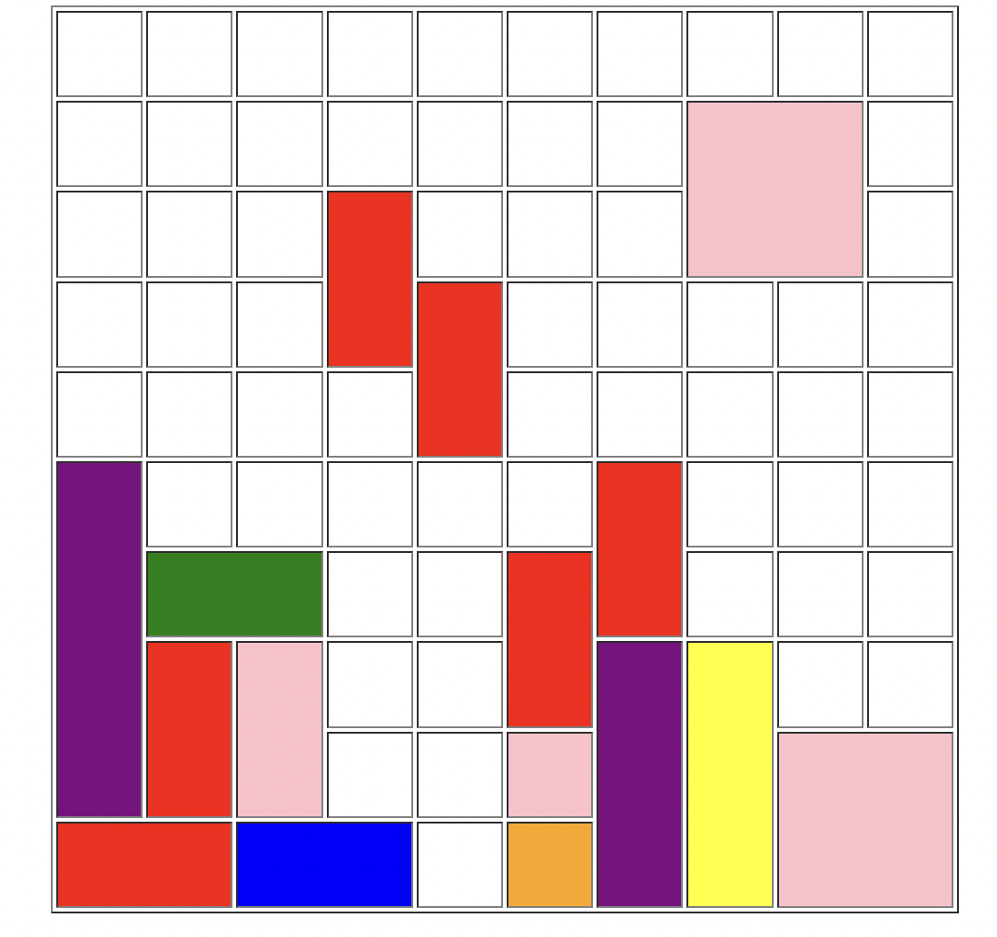

**#실습2**

**-코드**

<HTML>

<head>

<title>2022 CAT-Security</title>

</head>

<body>

<h1 align='center'>자기소개서</h1>

<table border="1" width='700px' height='500px' align="center" name='name'>

<form method="post" action="" name="form">

<tr valign='left' >

<td width="100px">이름</td> <td width="800px"><input type="text" name="itext"/></td><br>

</tr>

<tr valign='left'><td width="50">

아이디 </td><td><input type="password" name="ipassword"/><br>

</tr>

<tr ><td width="50">

성별 </td><td><input type="radio" name="iradio1"/>남

<input type="radio" name="iradio" value="radio2"/>여<br></td></tr>

<tr width="50" ><td width="50">

나이</td><td><input type="checkbox" name="icheckbox" value="checkbox1"/>20

<input type="checkbox" name="icheckbox" value="checkbox2"/>21

<input type="checkbox" name="icheckbox" value="checkbox3"/>22<br>

<input type="checkbox" name="icheckbox" value="checkbox3"/>23

<input type="checkbox" name="icheckbox" value="checkbox3"/>24<br>

</td></tr>

<tr width="50" ><td>

주량 </td><td><select name="iselect">

<option value="솔직하게 선택하세요.">솔직하게 선택하세요.</option>

<option value='1'>1</option>

<option value="2">2</option>

</tr></td>

</select><br>

<tr valign='center' ><td align="center" colspan="2" rowspan="1">

자기소개서</tr></td>

<br>

<td align="center" colspan="2" rowspan="1"><textarea rows='10' cols='50' name="itextarea">400자 이상 입력하세요.</textarea></td>

</tr><br>

<br>

<tr valign='left' ><td>

사진 첨부 </td><td><input type="file" name="ifile"/><br>

</td></tr>

<tr valign='center' ><td align="center" align="center" colspan="2" rowspan="1">

<input type="submit" value="가입신청">

</td></tr>

</form>

</tr>

</table>

</body>

</html>

**-결과 화면**

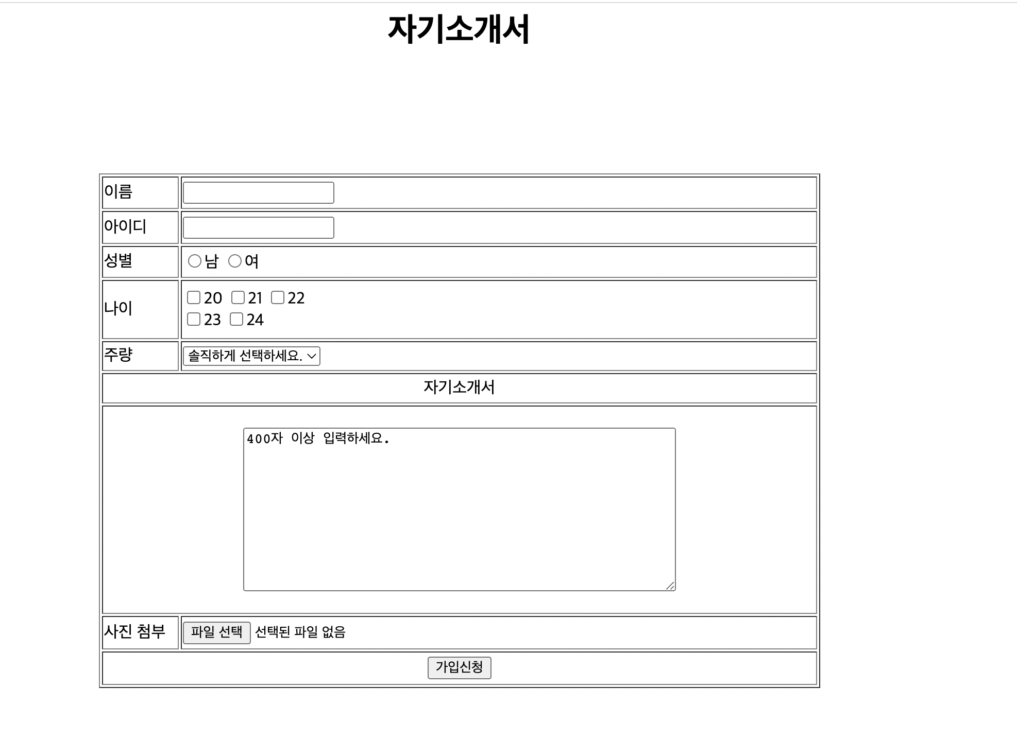

**#실습3**

**-코드**

<html>

<head>

<title> 2022 CAT-CERT HTML TAG</title>

</head>

<body>

<iframe width="40%" height="40%" src="https://www.nate.com"></iframe>

<iframe width="40%" height="40%" src="https://www.catsecurity.net"></iframe>

<iframe width="40%" height="40%" src="https://e-cyber.catholic.ac.kr/ilos/main/main_form.acl"></iframe>

<iframe width="40%" height="40%" src="https://www.daum.net"></iframe>

</body>

</html>

**-실행 화면**

* **HTTP Method(데이터 전송방식) 3가지 이상 조사**

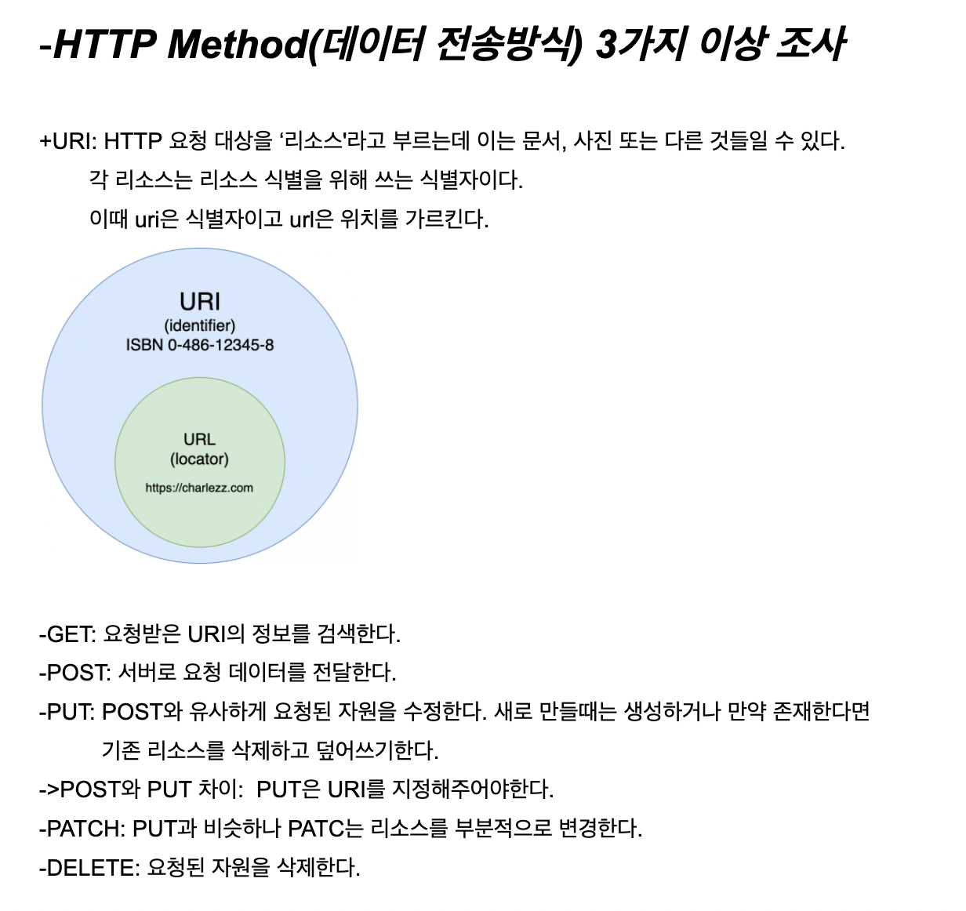

* **HTTP 응답 코드 5가지 이상 조사**

**-회원가입 폼 만들기**

**-참고한 회원가입 폼(출처:** **https://coinco.tistory.com/90)**

**-코드**

<HTML>

<head>

<title>2022 CAT-Security</title>

</head>

<body>

<h1 align='center'>회원가입하기</h1>

<table border="1" width='700px' height='500px' align="center" name='name'>

<form method="post" action="" name="form">

<tr valign='left' >

<td width="100px">이름</td> <td width="800px"><input type="text" name="itext"/></td><br>

</tr>

<tr valign='left' >

<td width="100px">주소</td> <td width="800px"><input type="text" name="itext"/></td><br>

</tr>

<td valign='center' width="10" colspan="1" rowspan="2">

자기소개

</td><br>

<tr><td><textarea rows='10' cols='50' name="itextarea"></textarea><br>

</td></tr>

<tr width="50" ><td width="50">

취미</td><td><input type="checkbox" name="icheckbox" value="checkbox1"/>TV

<input type="checkbox" name="icheckbox" value="checkbox2"/>독서

<input type="checkbox" name="icheckbox" value="checkbox3"/>컴퓨터

<input type="checkbox" name="icheckbox" value="checkbox3"/>영화감상

</td></tr>

<tr ><td width="50">

성별 </td><td><input type="radio" name="iradio1"/>남

<input type="radio" name="iradio" value="radio2"/>여<br></td></tr>

<tr vwidth="50" ><td>

직업 </td><td><select name="iselect">

<option value="솔직하게 선택하세요.">직업선택</option>

<option value='1'>대학생</option>

<option value="2">군인</option>

<option value="2">회사원</option>

</tr></td>

</select><br>

<tr valign='left'><td width="50">

아이디</td><td><input type="password" name="ipassword"/><br>

</tr>

<tr valign='left'><td width="50">

암호</td><td><input type="password" name="ipassword"/><br>

</tr>

<tr valign='left'><td width="50">

암호확인</td><td><input type="password" name="ipassword"/><br>

</tr>

<tr valign='center' ><td align="center" align="center" colspan="2" rowspan="1">

<input type="submit" value="가입하기"> <input type="submit" value="다시작성">

</td></tr>

</form>

</tr>

</table>

</body>

</html>

**-실행화면**

**-개인시간표 만들기**

**-코드**

<html>

<head>

<title>HTML TAG</title>

</head>

<body>

<table border='1' width='500px' height='500px' align='center' name='mytable'>

<tr>

<td> </td>

<td align="center" width="20%"> 월 </td>

<td align="center" width="20%"> 화 </td>

<td align="center" width="20%">수</td>

<td align="center" width="20%">목</td>

<td align="center" width="20%">금</td>

</tr>

<tr>

<td height="10%">9</td>

<td></td>

<td colspan="1" rowspan="3" style="background-color:pink">일반수학및연습</td>

<td></td>

<td></td>

<td></td>

</tr>

<tr>

<td height="10%">10</td>

<td></td>

<td></td>

<td colspan="1" rowspan="2" style="background-color:pink">일반수학및연습</td>

<td></td>

</tr>

<tr>

<td height="10%">11</td>

<td></td>

<td></td>

<td></td>

</tr>

<tr>

<td height="10%">12</td>

<td colspan="1" rowspan="2" style="background-color:red;">한국근현대사회의역사와문화</td>

<td></td>

<td colspan="1" rowspan="2" style="background-color:blue;">인간학1</td>

<td></td>

<td colspan="1" rowspan="1" style="background-color:orange;">한국근현대사회의역사와문화</td>

</tr>

<tr>

<td height="10%">1</td>

<td></td>

<td></td>

<td></td>

</tr>

<tr>

<td height="10%">2</td>

<td></td>

<td></td>

<td></td>

<td></td>

<td></td>

</tr>

<tr>

<td height="10%">3</td>

<td></td>

<td colspan="1" rowspan="2" style="background-color:green;">컴퓨터와프로그래밍1</td>

<td></td>

<td colspan="1" rowspan="2" style="background-color:green;">컴퓨터와프로그래밍1</td>

<td colspan="1" rowspan="1" style="background-color:yellow;">일반물리학</td>

</tr>

<tr>

<td height="10%">4</td>

<td colspan="1" rowspan="2" style="background-color:yellow;">일반물리학</td>

<td colspan="1" rowspan="2" style="background-color:orange;">키스톤디자인인문창의</td>

<td colspan="1" rowspan="2" style="background-color:yellow;">일반물리학실험</td>

</tr>

<tr>

<td height="10%">5</td>

<td></td>

<td></td>

</tr>

<tr>

<td align="center" colspan="6" rowspan="1">생애진로와커리어디자인</td>

</tr>

</table>

</body>

</html>

**-실행 화면**

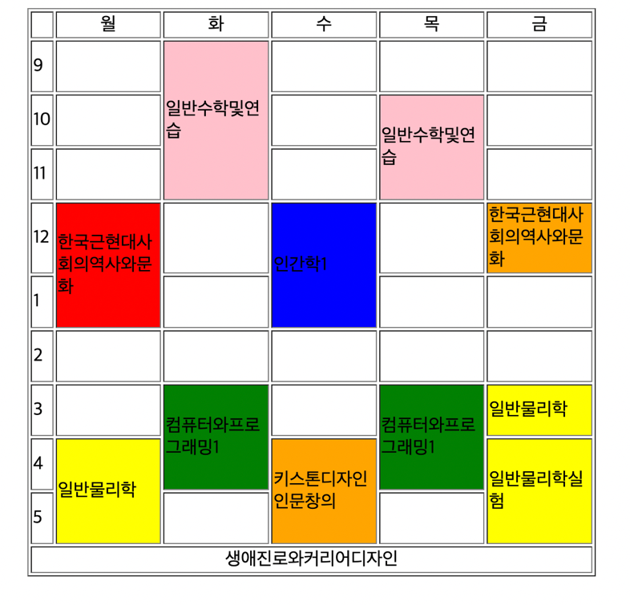

* **GIT , github 조사해오기**

* **GIT 명령어 (add , commit, remote, push, pull 등 )**

* ***Github 가입하기***

